RECIPE  
Homemade Sweetened Condensed Milk

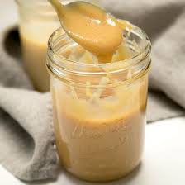

# Ingredients

* 3.5 cups milk (preferably whole)
* ½ cup heavy cream
* 1 cup sugar

# Preparation

1. Combine the three ingredients into a medium saucepan and heat on medium high until caramel colored and reduced to about 1 ¼ cups. Stir frequently and do not let overbol or curdle.